# INDIAN INSTITUTE OF TECHNOLOGY INDORE Minor Project: CS-207

**Prakhar Rai(180001035) Naman Jain(180001031)**

METRO RAILWAYS DATABASE MANAGEMENT

**PROBLEM STATEMENT**

The increasing levels of congestion on Jaipur road network coupled with high private vehicle usage prompted the planners and the implementing agencies to go for transportation infrastructure improvements.

The proposed system “Metro Rail Management System” is developed for tackling the problems in the existing system. Easy to use and provides accurate information to the user for taking necessary decisions.The information provided will be accurate and unambiguous, efficiency-information can be collected, processed and communicated more quickly and efficientlys and systems ensure that right information reaches the right person at the right time.0

This is an integrated service which provide all information about the metro rail and it’s routes for public. The proposed system will be a web based application which provides information regarding timings, routes, fair.

This system will manage public feedback through it’s complaint management system. This system will also contain an online metro card recharge facility where users can recharge their smart cards online through the site.There will also be an admin page where admin can add stations, trains, routes and also update the fairs.

**FUNCTIONALITIES**

**ROUTEMAP**

The passengers will be able to get information regarding the stations falling in the route of the metro.. Users are required to enter the source and destination station, when they enter the data then the system will display route map.In this way they can confirm if their station lies on the route.

**METRO TIMETABLE**

Thisfeature will allow users to see the timetable of all the metros.They can accordingly plan their journey.

**FAIR**

This feature will allow the users to view the fair of their journey.Users are required to enter source and destination station.On entering data system will display the fair details.

**METRO CARD**

This feature is primilarly for the daily passengers like students,office- goers.This feature allows the user to issue and recharge their metro card online, thereby saving their valuable time. Users need to login with their card number & password.It also allows them to view their balance and journey history.

**REGISTER COMPLAINT**

This feature allows users to file complaints through the site. The user does not require a registration. He can give his name, email-id, phone number, address and other details along with the complaints. The admin will reply to the complaints sent by user.

**LOST AND FOUND**

Users can upload information regarding any lost item or any item they find in metro along with their details. Admin can then review the lost/found information and can accordingly display it on the website.

**ADMIN SECTION**

The Admin is the owner of the site and the administrator account has full privileges and control over the whole database and has the ability to add/edit/delete any information stored in the database.This feature allows the admin to view and reply to complaints. Admin can add stations, routes ,train , trip . Admin can also add and update fair details, and even add a new admin. Actually, the admin is a panel consisting of a group of authorized persons.

**E-R ANALYSIS**

**Entity relation between train and station**

**1.Train**

**.TRAIN_ID**

**.TRAIN_NAME**

**.CAPACITY**

**2.STATION**

**.STATION_ID**

**.STATION_NAME**

**3.VISITS TO(R)**

**This is a relation from entity set(Train) to entity set (Station) .**

**Entity relation between train and route**

**1.Train**

**.TRAIN_ID**

**.TRAIN_NAME**

**.CAPACITY**

**2.ROUTE**

**.ROUTE_ID**

**.SOURCE**

**.DESTINATION**

**3.FOLLOWS(R)**

**This is the relation from train entity set to route entity set.**

**Entity relation between Station and route**

**1.STATION**

**.STATION_ID**

**.STATION_NAME**

**2.ROUTE**

**.ROUTE_ID**

**.SOURCE**

**.DESTINATION**

**3.Contains(R)**

**This is the relation from ROUTE entity set to STATION entity set.**

**Entity relation between Station and Line**

**1.STATION**

**.STATION_ID**

**.STATION_NAME**

**2.LINE**

**.LINE_ID**

**.LINE_NAME**

**3.LIES ON(R)**

**This is a relation from set Station to set LINE.**

**Entity relation between Complain and Reply**

**1.COMPLAIN**

**.CMP_ID**

**.CMP_MESSAGE**

**.EMAIL**

**.CMP_DATE**

**2.REPLY**

**.REP_ID**

**.REP_MESSAGE**

**.REP_DATE**

**3.REPLY FOR(R)**

**This is a relation from set reply to set complain.**

**METRO MAP**

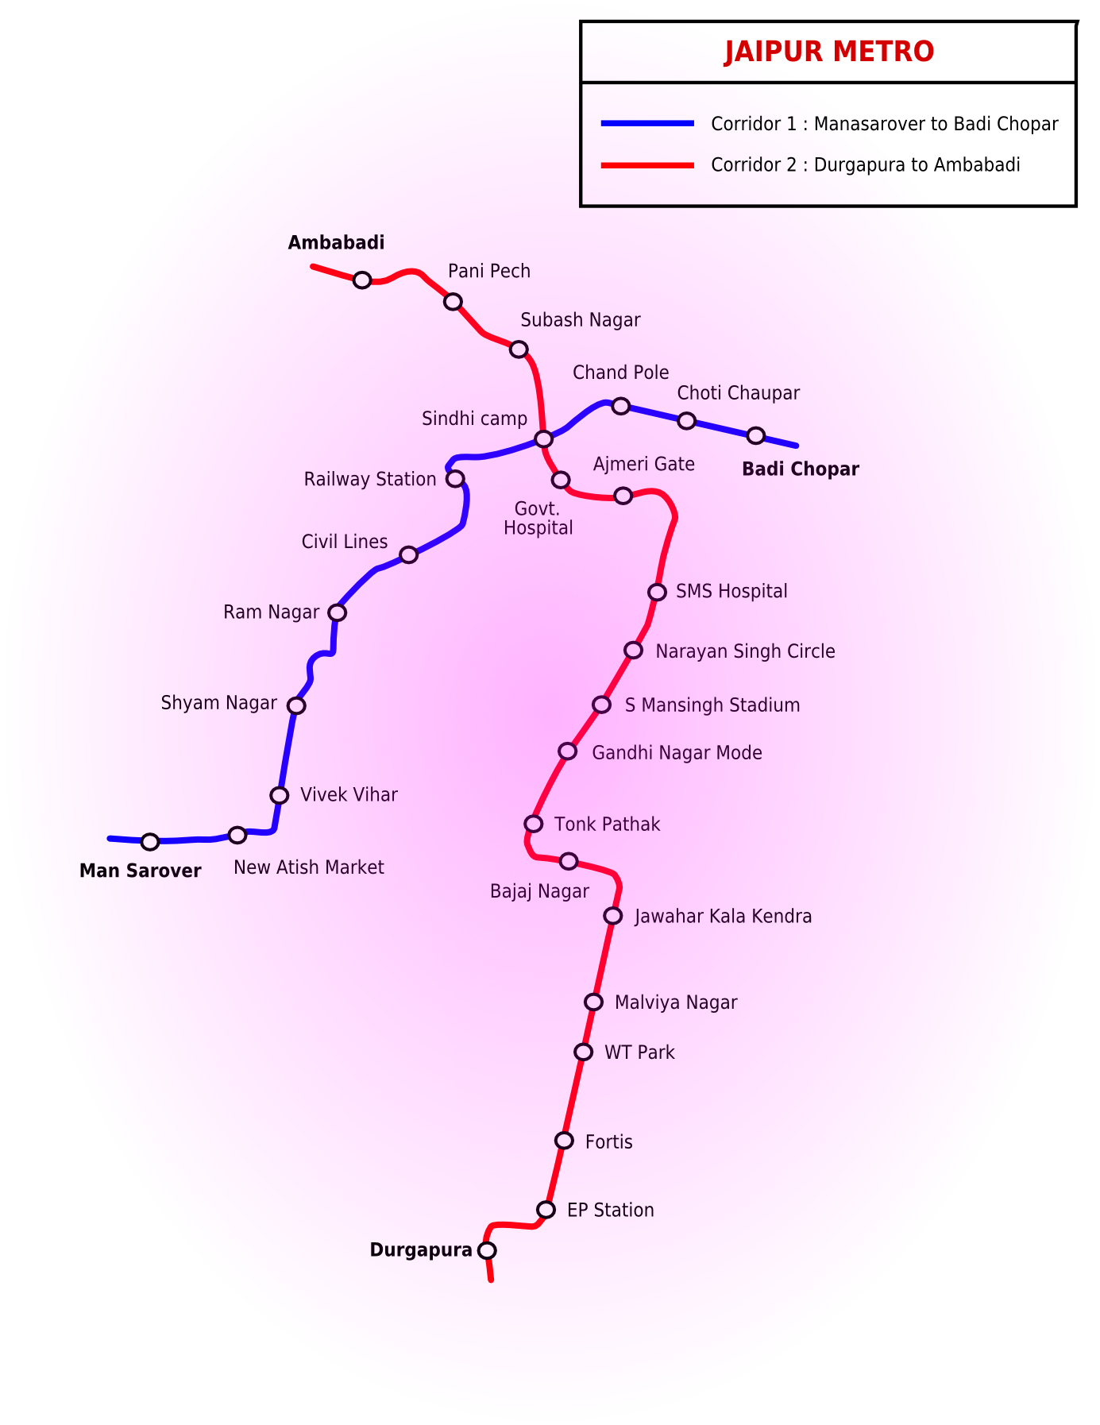

**E-R DIAGRAM**

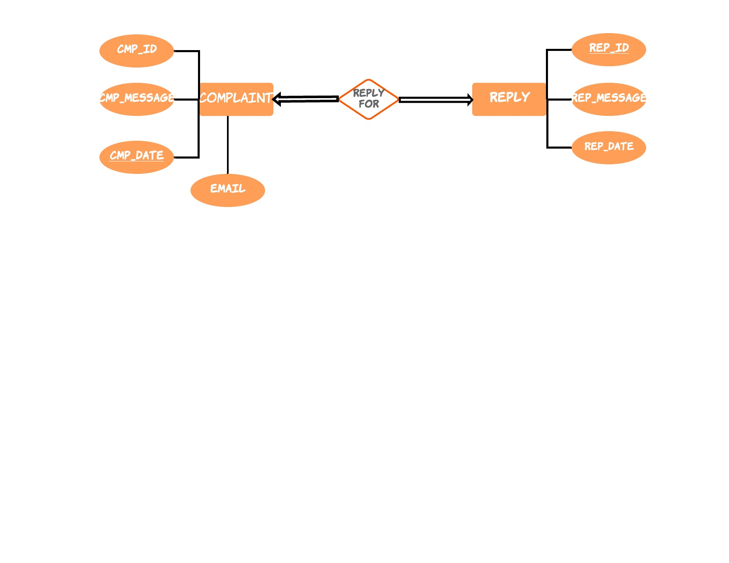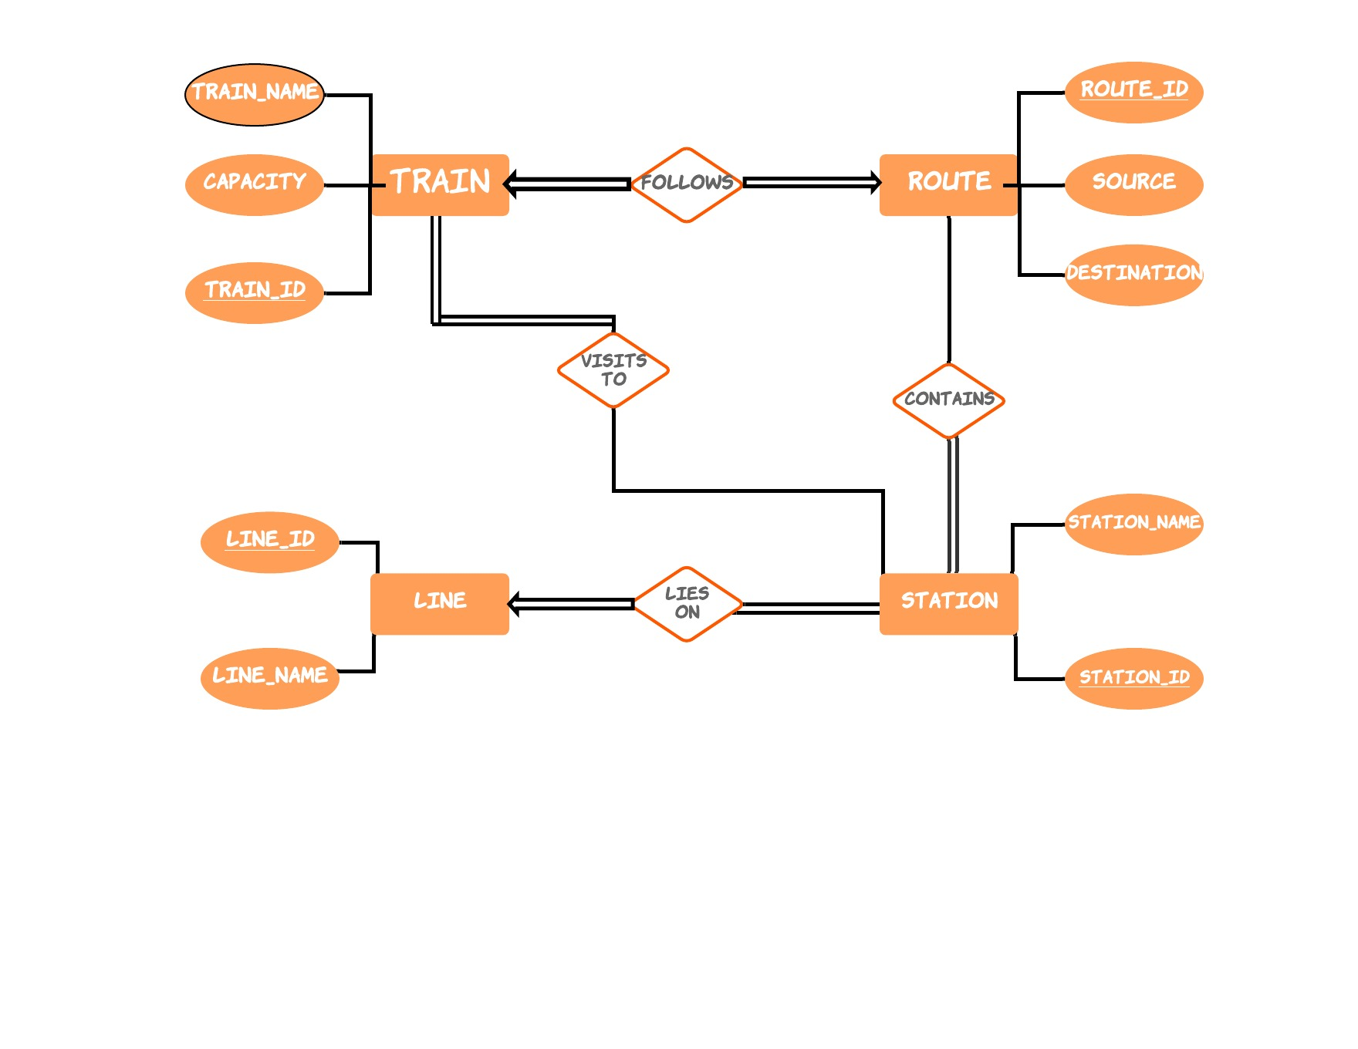

TABLES DEDUCED FROM E-R DIAGRAM

**1.TRAIN**

|  |  |  |
| --- | --- | --- |
| TRAIN_ID | NOT NULL | INT |
| STATION_ID | NOT NULL | INT |
| TRAIN_NAME | NOT NULL | VARCHAR(20) |
| CAPACITY | NOT NULL | INT |

**2.STATION**

|  |  |  |
| --- | --- | --- |
| STATION_ID | NOT NULL | INT |
| STATION_NAME | NOT NULL | VARCHAR(20) |
| ROUTE_ID | NOT NULL | INT |
| LINE_ID | NOT NULL | INT |

**3.ROUTE**

|  |  |  |
| --- | --- | --- |
| ROUTE_ID | NOT NULL | INT |
| SOURCE | NOT NULL | VARCHAR(20) |
| DESTINATION | NOT NULL | VARCHAR(20) |

**4.LINE**

|  |  |  |
| --- | --- | --- |
| LINE_ID | NOT NULL | INT |
| LINE_NAME | NOT NULL | VARCHAR(20) |

**5.COMPLAINTS**

|  |  |  |
| --- | --- | --- |
| CMP_ID | NOT NULL | INT |
| CMP_MESSAGE | NOT NULL | VARCHAR(200) |
| CMP_DATE | NOT NULL | DATE |
| EMAIL | NOT NULL | VARCHAR(20) |

**6.REPLY**

|  |  |  |
| --- | --- | --- |
| REP_ID | NOT NULL | INT |
| REP_MESSAGE | NOT NULL | VARCHAR(200) |
| DATE | NOT NULL | DATE |

**7.FOLLOWS(R)**

|  |  |  |
| --- | --- | --- |
| TRAIN_ID | NOT NULL | INT |
| ROUTE_ID | NOT NULL | INT |

**8.REPLY FOR(R)**

|  |  |  |
| --- | --- | --- |
| CMP_ID | NOT NULL | INT |
| REP_ID | NOT NULL | INT |

**CONCLUSIONS**

The system has been developed with much care and free of errors and at the same time it is efficient and less time consuming. The purpose of this project was to develop a web application for metro rail management . The entire system is secured. Also the project helps one understand about the development phases of a project and software development life cycle. Besides getting benefited for the knowledge gained this project is very useful in daily life and can be efficiently implemented or worked upon.